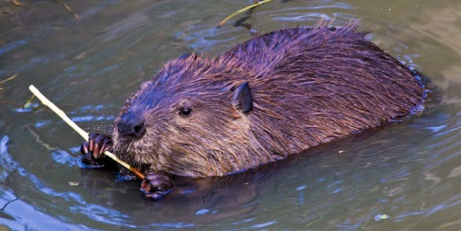58-99 cm (length, excluding tail)  Beavers  Eat: Willows  Eaten by: Gray wolves | 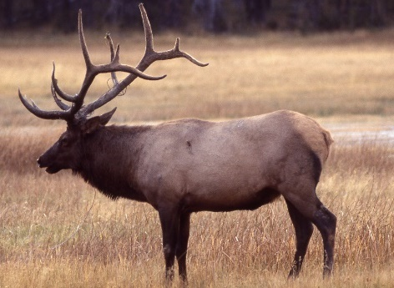  2.1-2.4 m  Elk  Eat: Grasses, willows,  other flowering  plants  Eaten by: Gray wolves,  grizzly bears,  coyotes | 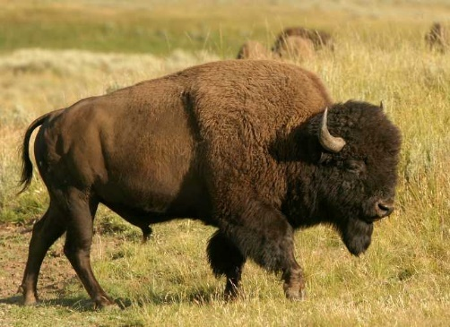  2.1-3.5 m  Bison  Eat: Grasses, willows  Eaten by: Gray wolves
http://g  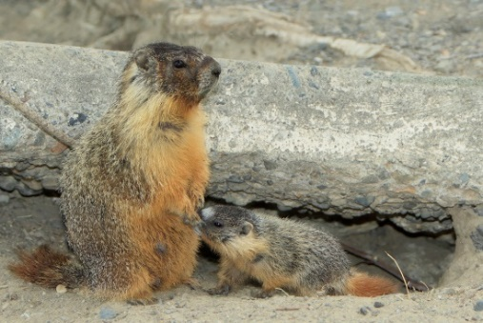  47-70 cm  Yellow-bellied  Marmots  Eat: Grasses; other  flowering plants  Eaten by: Coyotes | 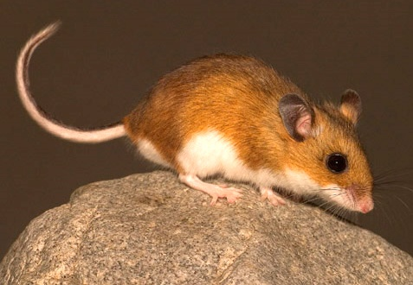  8-10 cm (length, excluding tail)  Deer Mice  Eat: Grasses; other  flowering plants  Eaten by: Coyotes | 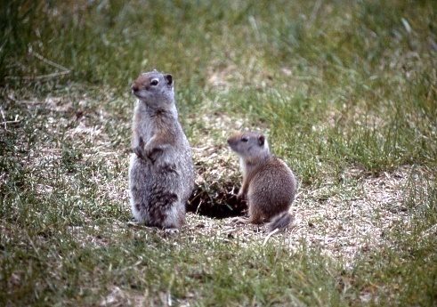  28-30 cm  Uinta Ground Squirrels  Eat: Grasses, other  flowering plants,  fungi  Eaten by: Coyotes,  grizzly bears

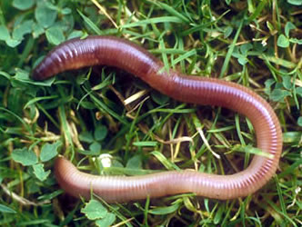  7-35 cm  Earthworms  Eat: Dead organic matter,  fungi, bacteria  Eaten by: American robins | 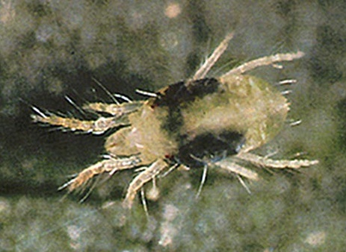  0.5-1 mm  Mites  Eat: Nematodes, fungi  Eaten by: Beetles | 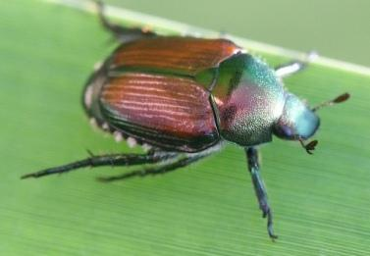  1-30 mm  Beetles  Eat: Springtails, mites  Eaten by: American  robins
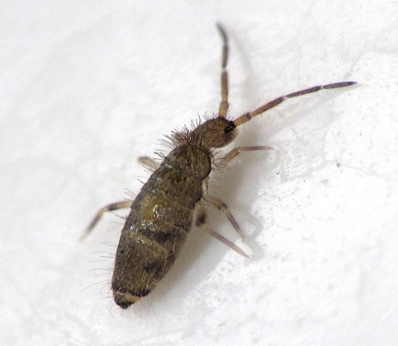  0.25-5 mm  Springtails  Eat: Fungi  Eaten by: Beetles | 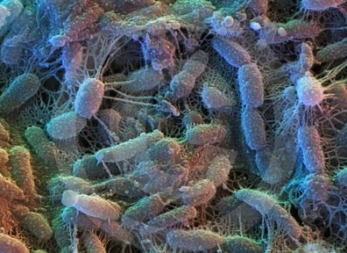  2-6 µm  Bacteria  Consume: Dead organic  matter  Eaten by: Protista,  nematodes,  earthworms | 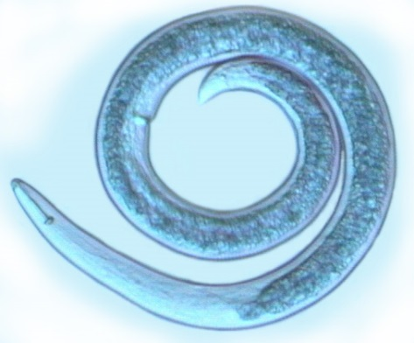  0.1-2.5 mm  Nematodes  Eat: Protista, fungi,  bacteria  Eaten by: Mites

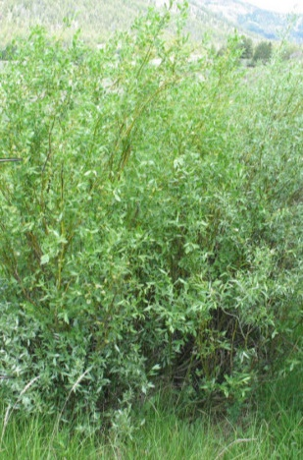  <80-400 cm  Willows  Eaten by: Beavers, elk, bison | 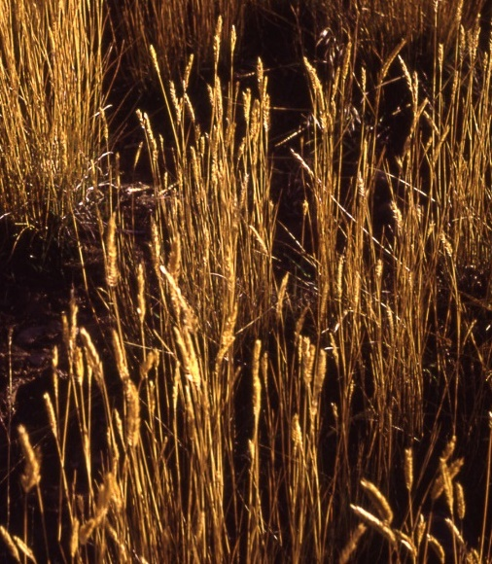  Grasses (including seeds)  Eaten by: Bison, elk, deer  mice, Uinta ground  squirrels, yellow-  bellied marmots | 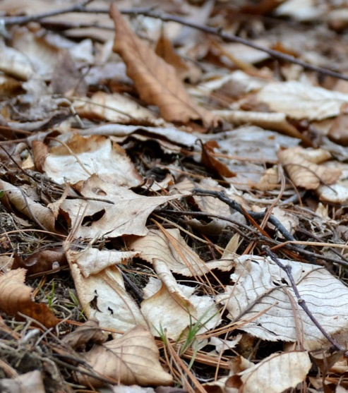  Dead Organic Matter  Consumed by: Bacteria,  fungi, earthworms
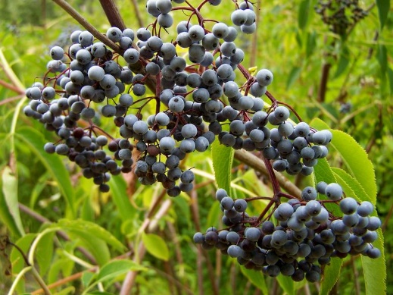  Other flowering plants  (including berries)  Eaten by: American  robins, deer mice,  elk, grizzly bears,  Uinta ground  squirrels, yellow-  bellied marmots | 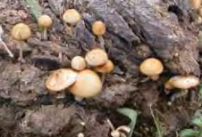  Fungi  Consume: Dead organic  matter  Eaten by: Springtails,  mites, nematodes,  earthworms,  Uinta ground squirrels | 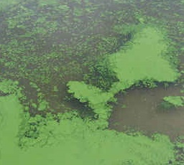  Algae  Eaten by: Cutthroat trout

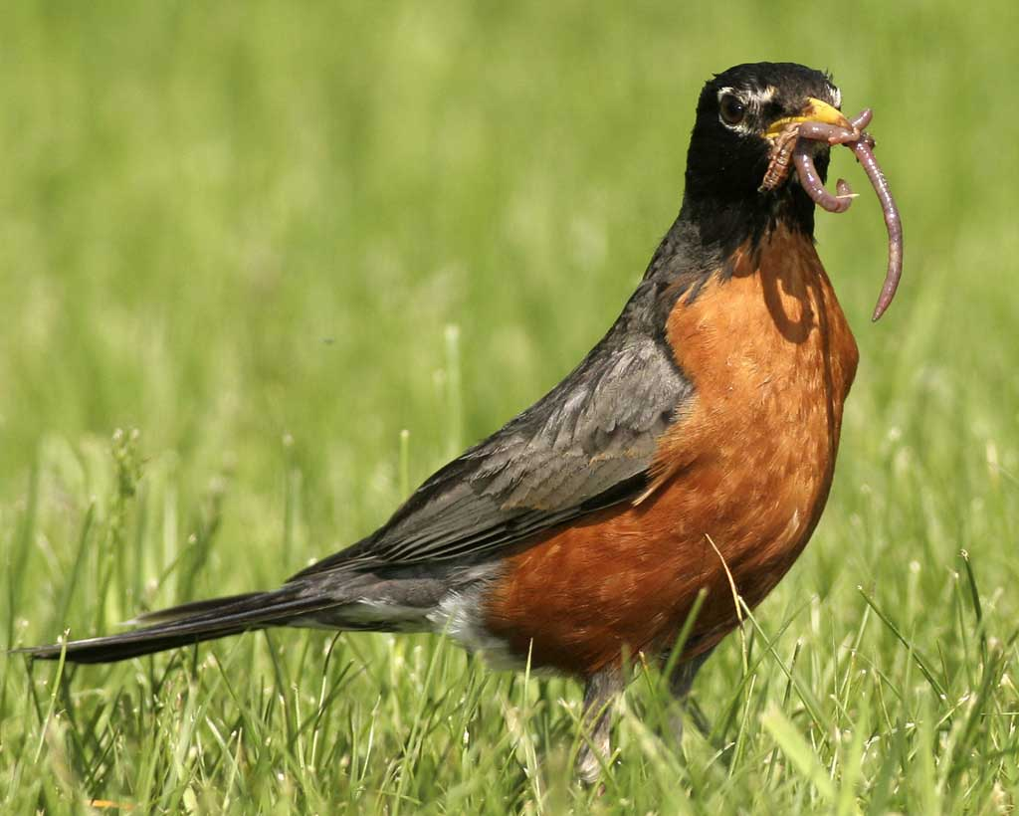  23-28 cm  American Robins  Eat: Earthworms, beetles,  other flowering plants  Eaten by: Snakes and  birds of prey (not  included in this food web) | 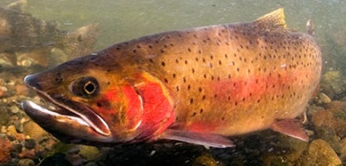  15-50 cm  Cutthroat Trout  Eat: Algae  Eaten by: Grizzly bears | 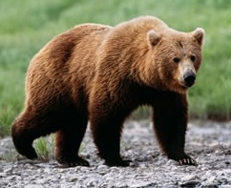  1.8-3.3 m  Grizzly Bears  Eat: Other flowering  plants, cutthroat  trout, Uinta ground  squirrels, elk
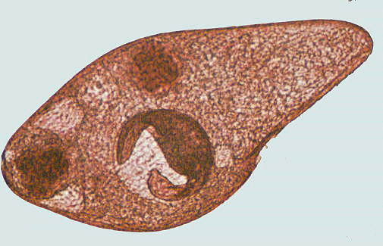  <1 mm  Protista  Eat: Bacteria  Eaten by: Nematodes | 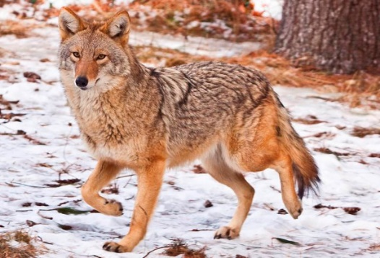  1-1.4 m  Coyotes  Eat: deer mice, Uinta  ground squirrels,  yellow-bellied  marmots, elk  Eaten by: Gray wolves | 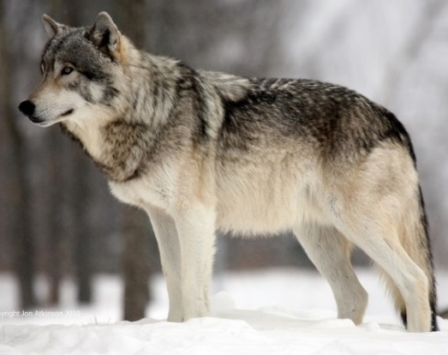  1.4-2 m  Gray Wolves  Eat: Elk, beavers, bison,  coyotes

